**Abstraction** is a process of hiding the implementation details and showing only functionality to the user. Another way, it shows only important things to the user and hides the internal details

**Example** : when you consider the case of e-mail, complex details such as what happens as soon as you send an e-mail, the protocol your e-mail server uses are hidden from the user. Therefore, to send an e-mail you just need to type the content, mention the address of the receiver, and click send.

A class which contains the **abstract** keyword in its declaration is known as **abstract** class.

* Abstract classes **may or may not** contain *abstract methods*, i.e., methods without body (public void get(); ) Abstract class can contain non-abstract methods. It is ok if we declare class and do not have any abstract method in it.
* But, if a class has at least one abstract method, then the class **must** be declared abstract.
* If a class is declared abstract, it cannot be instantiated. i.e. **we** **cannot create an object**. But with child class’s object, we access Abstract class’s non-abstract methods.
* To use an abstract class, you have to inherit it from another class, provide implementations to the abstract methods in it.
* If you inherit (**Extend**) an abstract class, you have to provide implementations to **all the abstract** methods in it.
* A method defined abstract must always be redefined in the subclass, thus making [overriding](http://write.geeksforgeeks.org/overriding-in-java/) compulsory OR make subclass itself abstract.
* An abstract class can have parameterized constructors and default **constructor** is always present in an abstract class. Abstract class constructor will be invoked when **child** class object will be created
* ABSTRACT method can **have** **return** type
* IMP : Parent child references : if parent’s reference and child’s object created, then parent’s reference cannot access child's local methods.
* **final** : Abstract method cannot be **final**. We have to override abstract method, and if a method is final, then we can’t override it.
* **Static** : **An abstract method cannot be static**. If you declare a method in a class abstract to use it, you must override this method in the subclass. But, overriding is not possible with static methods.
* **Private** : the abstract method **cannot be private**. If a method of a class is private, you cannot access it outside the current class. But, incase of an abstract method, you cannot use it from the same class, you need to override it from subclass and use, so, abstract method cannot be private.
* **Protected** : **Yes**, you can declare an abstract method protected. If you do so you can access it from the classes in the same package.

Key Word Abstract should come **first** in class and method declaration in order to let the compiler know that it is abstract. Ex. : abstract class aa { … } OR abstract void add() { … }

**we** **cannot create an object**. But with child class’s object, we access Abstract class’s non-abstract methods.

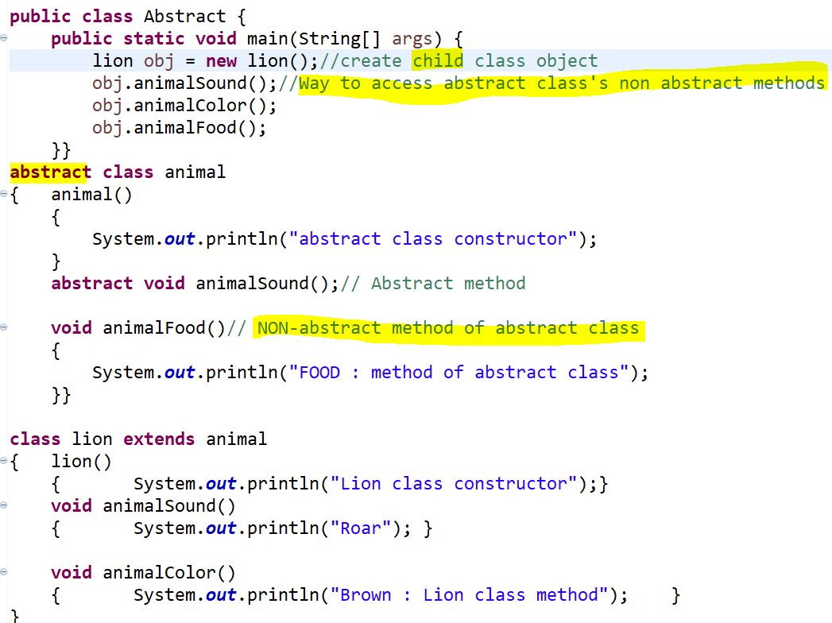

if parent’s reference and child’s object created, then parent’s reference cannot access child's local methods.